Hyperlipidemia

* TC= LDL+HDL+VLDL VLDL = TG/5
  + *Friedewald equation:* LDL = (TC-HDL)-(TG/5)
    - NOTE: loss of accuracy with TG>400mg/dl

*Total Cholesterol(mg/dL)= LDL + HDL + VLDL Classification of Serum TGs = VLDL * 5*

<200 Desirable <150mg/dL Normal

200-239 Borderline high 150-199mg/d Borderline high

>240 High 200-499mg/dL High

>500mg/dL Very high

*LDL Cholesterol (mg/dL) HDL Cholesterol (mg/dL)*

< 100 Optimal <40 Low

100-129 Near optimal >60 High (a negative risk factor -1)

130-159 Borderline High (ok if no risk factor)

160-189 High

>190 Very high

**CHD & Risk Equivalent use Therapeutic Life Change + Rx**

* CHD (Coronary Heart Disease)
  + MI
  + Angina
  + Prior unstable angina
  + Coronary Bypass graft
  + Coronary Angioplasty (temporary widening) and or stent placement
* CHD Risk Equivalent
  + 10 year risk for CHD > 20%
  + DM
  + Artery
    - *Carotid artery disease,* Stroke hx, TIA (Transient Ischemic Attack), cartoid stenosis (>50%)
    - CAD (Coronary Artery Disease) + Metabolic Syndrome
    - 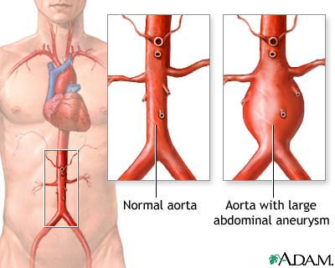Peripheral arterial disease: Claudication, ABI <0.9 Peripheral artery disease is a common circulatory problem in which narrowed arteries reduce blood flow to your limbs
    - Abdominal aortic aneurysm

**Major risk factors (if 2 or more risk factors, calculate Framingham score)**

* Age (**M**en >45yrs; women >55yrs)
* Cigarette Smoking
* Hypertension
  + BP >140/90mmHg or on antihypertensive medication
* Low **H**DL cholesterol* (<40mg/dL)
* Family hx of premature CHD
  + CHD in male first degree relative <55yrs
  + CHD in female first degree relative <65yrs

|  |  |  |  |
| --- | --- | --- | --- |
| **Risk Category** | **LDL level at which to initiate TLC**  **For 3 months** | **LDL level at which to consider drug tx** | **LDL Goal**  **(mg/dL)** |
| CHD **and**  Multiple risk factors  Or Metabolic Syndrome | If LDL > 100  Start TLC & tx |  | goal:<70mg/dL |
| CHD or  CHD risk equivalent:  2+ Risk Factor (10-yr risk >20%), DM, Artery | If LDL > 100  Start TLC & tx | If LDL > 100  Start Therapeutic lifestyle change | <100  goal:<70mg/dL |
| 2+ Risk Factors (10-yr risk 10-20%) | If LDL > 130  Start Therapeutic lifestyle change | If LDL is > 130 mg/dL  After 3 months of TLC | goal:<100mg/dL) |
| 2+ Risk Factors (10-yr risk <10%) | >130 | >160  After 3 months of TLC | <130 |
| 0-1 Risk Factors (10-yr risk <10%) | >160 | >190  After 3 months of TLC | <160 |

Major Lipids Found in body

1. Cholesterol
   1. Source? Synthesized in liver, small intestine and in diet
   2. Use? Cell membrane, steroids, bile acids
2. Triglycerides
   1. Found in? plasma lipids
   2. Use? Stores energy
3. Phospholipids
   1. Found in? all cellular membranes contain phospholipids

Lipoprotein is a biochemical assembly that contains both proteins and lipids water-bound to the proteins

1. Use: transport? Transport triglycerides from the gut and liver to fat or muscle
   * 1. Peripheral tissue for membrane synthesis and for hormone production
     2. Liver bile acid synthesis
   1. Source?
      1. Exogenous System
      2. Endogenous System
2. Outer Surface (polar)
   1. Phospholipids
   2. Apolipoproteins
   3. Free cholesterol
   4. Apolipoproteins Protein moieties of lipoprotein on the outer surface
      1. Function? Provide structure, activate enzyme systems, marker for cell surfaces
      2. Dysfunction of Apo = may lead to HDL deficiency
3. Inner core
   1. Cholesterol esters
   2. Triglycerides

|  |  |  |  |  |  |  |
| --- | --- | --- | --- | --- | --- | --- |
| Lipoprotein  /Major Apo | Origin | Density  (g/ml) | Size  (nm) | %  protein | Cholesterol in plasma* | TG in plasma* |
| Chylomicrons  B48 | Intestine | <0.95 | 100-1000 | 1-2 | 0.0 | 0 |
| VLDL  B100 | Liver/Intestine | <1.006 | 40-50 | 10 | 0.1-0.4 | 0.2-1.2 |
| IDL  B100,E | VLDL | 1.006-1.019 | 25-30 | 18 | 0.1-0.3 | 0.1-0.3 |
| LDL  B100 | IDL | 1.019-1.063 | 20-25 | 25 | 1.5-3.5 | 0.2-0.4 |
| HDL  AI | Liver/Intestine | 1.063-1.210 | 6-10 | 40-55 | 0.9-1.6 | 0.1-0.2 |
| Lp(a)  B100,(a) | Liver | 1.051-1.082 | 25 | 30-50 | -- | -- |

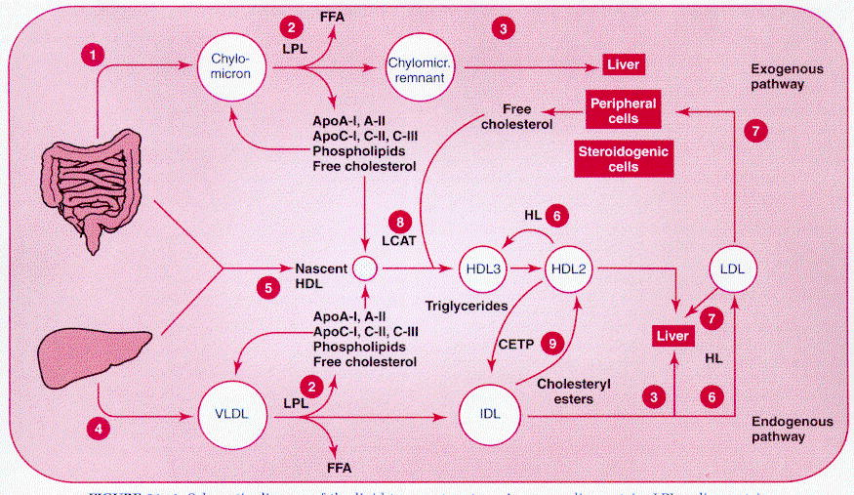

Lipoprotein Endogenous Pathway

IDL

FFA free fatty acid (for energy)

Apolipoproteins

Free cholesterol

Phospholipids

Liver synthesizes VLDL

50% IDL taken into liver

50% catabolized to LDL

Reverse Choelsterol Transport System

Intestine

&

Liver

HDL2 takes up IDL and CETP back into the liver

HDL3 and HDL2

Nascent HDL (new)

Artery

Structure of a normal artery

1. Intima innermost layer
   1. Type of cell? Tight endothelial cell
2. Tunica media
   1. Type of cell? SM cell
3. Adventitia
   1. Type of cell? Connective tissue, fibroblast, SM

Evolution of Plaque

1. Accumulation of LDL in arteries
   1. HTN accelerates diffusion of LDL
2. Adhesion
   1. Caused by dysfunctional endothelial cells
   2. Modification of LDL
      1. How? Smoking, diabetes
3. Adhesion causes monocyte initiation
   1. What’s a monocyte? A type of WBC that is of the innate immune system
   2. Chemokines (MCP-1) signal monocytes
      1. What augments chemokines? Angiotensin II
4. Monocytes take in oxidized LDL Monocytes + LDL = Foam cells
5. Buildup of cells

Cause of Hyperlipidemia Hyperlipidemia: Cause and Risk factors

1. MI
2. Unstable Angina
3. Ischemic Stroke
4. Critical Leg Ischemia
5. CV death

Secondary cause of Hyperlipidemia

1. Liver
   1. Obstructive liver disease
   2. Cirrhosis (scarring of the liver)
2. Glucose/Lipid
   1. Diabetes
   2. Glycogen storage disorders
   3. Cushing’s syndrome
   4. Lipodystrophy
3. Renal
   1. Chronic renal failure
   2. Nephrotic syndrome
   3. Glomerulonephritis
4. Hypothyroidism
5. Metabolic Syndrome: Definition? Combination of medical disorders that might lead to Lipid, CV, DM
   1. Diagnosed with 3 out of 5 to have syndrome
   2. Waste circumference?
      1. Male? > 40 inches
      2. Female? > 35 inches
   3. Atherogenic dyslipidemia
      1. TG levels? > 150 mg/dL
   4. Low HDL
      1. Male? < 40 mg/dL
      2. Female? < 50 mg/dL
   5. BP? > 130/85
   6. Insulin resistance
      1. Fasting blood glucose? > 110 mg/dL
6. Drug Induced
   1. Alcohol
   2. Progestins increase weight
   3. Glucocorticoids
   4. Thiazide (> 50 mg) Various types of thiazide diuretics used in high doses increase total cholesterol . levels by approximately 4% and increase serum LDL-C levels by 10%
   5. Beta Blockers
   6. Cyclosporine immunosuppressant for transplants
   7. Isotretinoin
   8. Protease Inhibitors

Risk Factors (already mentioned on pg1)

* + - 1. Age
         1. Male >45
         2. Female >55
      2. Smoking
      3. HTN > 140/90
      4. HDL lower than? < 40 mg/dL
      5. Family history of premature CHD
         1. Male <55
         2. Female <65

Emerging Risk Factors

1. Factors associated with increase Atherosclerotic vascular disease
   1. C-Reactive protein Marker of inflammation, acute phase reactant
   2. Apolipoprotein B Atherogenic lipoproteins (VLDL and LDL)
   3. Homocysteine AA by product, decrease with high dose Vit B

Testing

ATP III Guidelines

1. Non-fasting Lipid Profile to see normal everyday levels
   1. When to test Fasting Lipid Profile?
      1. TC ? >200 mg/dL
      2. HDL ? < 40 mg/dL
2. Fasting Lipid Profile
   1. What age? 20 y/o
   2. How often? Every 5 years
   3. Test
      1. TC
      2. TG
      3. LDL
      4. HDL

Treatment: TLC

Therapeutic Lifestyle changes (TLC)

1. TLC diet will decrease LDL by ___%? 5 – 15
   1. Weight reduction/physical activity physical activity will increase HDL
   2. Reduce Intake of cholesterol
      1. Saturated fats ___? < 7%
      2. Dietary cholesterol ___? < 200 mg/day
   3. LDL lowering foods

Tx: HMG CoA Reductase Inhibitors

1. Mechanism: block HMG-CoA reductase to mevalonate the rate limiting step
2. Outcome
   1. Reduce TG by? 10 – 45%
   2. Reduce LDL by? 25 – 60%
   3. Raise HDL by? 5 – 15%
   4. Jupiter trial Proves ___? Statins reduce plasma C-Reactive protein 🡪 reduce inflammation
      1. What is the trial? Healthy LDL levels with high CRP 🡪 decrease in CRP by 37%
3. Dosing
   1. Dose based on percentage decrease
      1. Percent decrease = ___ (current – goal) / current
   2. Titrate to maximum dose
      1. How long till max titration? 4-6 weeks
4. ADR
   1. Myopathy: general term any disease of muscles
   2. Myalgia muscle ache WITHOUT Creatinine Kinase elevation
   3. Rhabdomyolysis (0.2% - 0.9%) Creatinine Kinase (CK) elevation over 10X normal
      1. Factors contributing to myopathy
         1. Age ? > 80
         2. Female. Why? lipophilicity
         3. Hepatic dysfunction. Why? CYP drug interactions
         4. Small body. Why? high BA
         5. Renal insufficiency. Why? limited protein binding
5. Contraindication
   1. Pregnancy Category X
   2. Drug Contraindications b/c CYP3A4 inhibitors avoid simvastatin and Lovastatin
      1. **Fibrates SF Gemfibrozil** 
         1. **Why? interferes with glucuronidation of statins 🡪 renal clearance**
      2. Antidepressant Nefazodone
      3. Antifungal ItraconAzole, KetoconAzole, PosaconAzole
      4. Macrolides ErythroMycin ClarithroMycin, HelithroMycin
      5. HIV protease Inhibitors -navir
      6. Immunosuppressant Cyclosporin
6. Drug-Drug interactions
   1. CYP 3A4
      1. K Channel Blockers (III) **Amiodarone**
      2. Calcium Channel blockers (IV) **Diltazem**, **nifedipine,** **verapamil** (limit does of statin)
      3. Grape fruit Juice
   2. CYP 2C9
      1. K channel blockers Amiodarone
   3. P-glycoprotein substrates OATP
7. Monitoring Parameters
   1. Muscle pain (possibly rhabdo)
   2. Lipid profile _6 weeks_ after dose change, then Q 6 mo long term.
   3. LFTs (liver function test) at baseline, _3 months_, and periodically thereafter.
   4. CPK (Creatine Phosphokinase) at baseline and if the patient has symptoms of myalgia.
   5. Pregnancy Category X

Treatment: Statin Drugs

Least potent -------------------------------------------------------------------------------------------------------🡪 Most potent

|  |  |  |  |  |  |  |  |
| --- | --- | --- | --- | --- | --- | --- | --- |
| % LDL-C =  (Current-goal)  /(current) | Fluvastatin | Pravastatin  Pray 3 | Lovastatin | Pitavastatin | SiMvastatin | **A**torvastatin  Lipitor | Rosuvastatin  CRestor |
| 30 % | 40 mg | 20 mg | 20 mg | 1 mg | 10 mg |  |  |
| 38 % | 80 mg | 40 mg | 40 or 80 mg | 2 mg | 20 mg | 10 mg |  |
| 41 % |  | 80 mg | 80 mg | 4 mg | 40 mg | 20 mg | 5 mg |
| 47 % |  |  |  |  | 80 mg | 40 mg | 10 mg |
| 55 % |  |  |  |  |  | 80 mg | 20 mg |
| 63 % |  |  |  |  |  |  | 40 mg |
|  |  |  |  |  |  |  |  |
| CYP | CYP 2C9 | Hydroxylation  Oxidation  Conjugation  (hydrophilic) | CYP 3A4  <3 | Glucuronidation  Pit of glucose | CYP 3A4  M = 3 | CYP 3A4  Ator = 3A4 | 10% CYP 2C9  Crestor = C  (hydrophilic) |
| Advantage |  |  |  |  | sucks | Good for patients with low GFR | Highest LDL-C |

* Rule of 6 (6%)
* 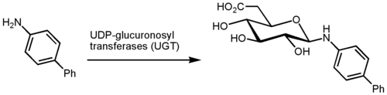Note that the difference in LDL-C is not 6-7% average. Conclusion: 1st dose will help LDL the most

2nd line treatments

2nd line treatments

Bile Acid Resins

MOA:

binds to bile acids in the gut

interrupts recycling through enterohepatic recirculation

as a result 🡪 hepatic cels convert cholesterol to bile acid

this causes a

Outcome

May Increase TG 3-10% statins derase by 10-45%

Reduce LDL by? 15-30% statins decrease by 25-60%

Raise HDL by? 3-5% statins raise by 5-15%

Advantage over Statins? No myopathy

Drugs

Colesevelam (Welchol) 2.6 – 8 grams 1-2 times a day

Cholestramine (Prevalite, Questran) 4-16 grams 2-4 times day

Colestipol( Colestid) powder 5-20 grams 2-4 times a day

Mix with pulpy juices

ADR

Decrease aborption of other drugs

How to solve? Dose 1-4 hr before other drugs are taken; or 4-6 hr after drugs are taken

GI distress

Increase fat soluble vitamins/folics (rare)

Contraindications

Nicotinic Acid (Niacin)

A. MOA:

* + - 1. Water Soluble B vitamin. Inhibits mobilization FFA (Free Fatty Acids) from peripheral adipose tissue to liver
      2. Decreases hepatic production VLDL (which decreases LDL production)

1. Drugs:
   1. Niacin 100 – 500 mg BID. Take with food
   2. Niaspan ER 500 -2g qHS
2. Outcome:

1. TG? 30 – 60%

2. LDL? 15 – 30%

3. HDL? + 20 – 25%

D. ADR

|  |  |
| --- | --- |
| IR | Flushing |
| ER | Hepatotoxicity |
| SR | Most Hepatotoxicity, least Flushing |

3. Hyperglycemia

4. hyperuricemia

Fibric Acid Derivatives

A. MOA

- Stimulation of peroxisome proliferator activated receptors (PPARα)

- suppresses synthesis of apolipoprotein C-III and stimulates LDL receptor synthesis leading to lipolysis of TG from VLDL particles and the removal of these particles via hepatic LDL receptors is increased

- increases fatty acid oxidation which reduces synthesis of TG in the liver

- may increase the synthesis apolipoprotein A-I, the building block of nascent HDL

B. Advantage: Decrease TG by 30-60%

Disadvantage ACCORD trial: Simvastatin + fenofibrate failed to show benefits in DM 2 patients

C. Drugs

Gemfibrozil 600 mg BID

Fenofibrate 67 – 200 mg daily

D. When to use?

1. TG is over 200 mg/dL

E Drugs

F. ADR/ contraindications

1. Myopathy with statins (especially Simvastatin)

2. Contraindicated in severe renal or hepatic disease

3. contraindicated in gall bladder disease

G. Monitor

1. Lipid profile every 6 weeks during dose titration

2. CPK if patient has symptoms of myalga

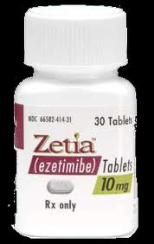Cholesterol Absorption Inhibitor

A. MOA: Impair dietary and billary cholesterol absorption

B. Advantage

Lowers LDL by 20%

Works well with Statins 🡪 additional 10-20% 🡪 combination therapy

Simvastatin + Ezetimibe

No rhabdo

Little D-D interactions

C. Drugs

Ezetimibe (Zeita)

D. ADR

Cyclosporine 🡪 lower cyclosporine levels

Fish Oils

A. MOA: Polyunsaturated Omega-3 Fatty acids

B. Advantage

Decreases TG by 30 – 60%

C. Drugs

Lovaza 1 gram/day for anti-inflammatory effect

2-4 grams/day for TG effect

D. GI upset